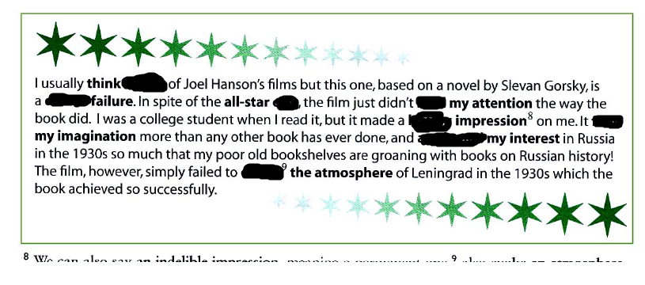

, cast , highly, long-lasting , spark, fire , hold , total , awaken

**glowing , highly, nail-biting , sensational , acclaimed ,**

- recommended

- plot

- climax

- reviews

- actor

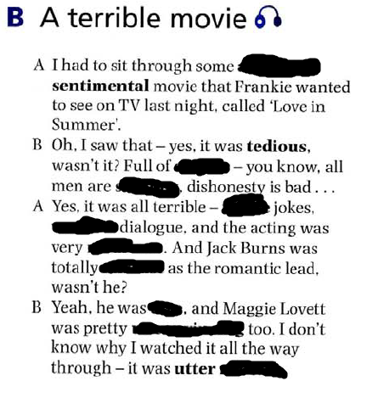

atrocious , rubbish , feeble, cliches , shallow , unconvincing, wooden, dire, miscast, mediocre